**CHETTINAD LEGENDARY ALUMNI WING**

**CHETTINAD DENTAL COLLEGE & RESEARCH INSTITUTE**

**CONTRIBUTION OF ALUMNI IN KIND/ NO OF BOOKS DONATED**

|  |  |
| --- | --- |
| TOTAL NUMBER OF ALUMNI PLACEMENT IN HIGHER STUDIES YEAR | **2023- 2024** |
| Total number of books contributed by alumni | **34** |
| Total number of books donated by alumni | **73** |
| Total number of alumni progressed to higher studies | **54** |

 

Secretary Treasurer

Dr. Ragavi V Dr. Bhuvaneswari

 

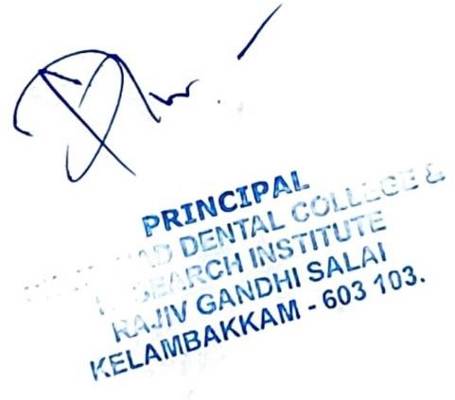

QUANTUM OF FINANCIAL CONTRIBUTION -2023-24

|  |  |  |
| --- | --- | --- |
| **YEAR** | **NO OF ENROLLED ALUMNI** | **ALUMNI CONTRIBUTION IN RUPEES** |
| 2023 -24 | 82+13 | **Rs. 1000** |
| **TOTAL** | **95** | **Rs. 95000** |

 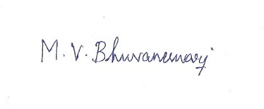

Secretary Treasurer

